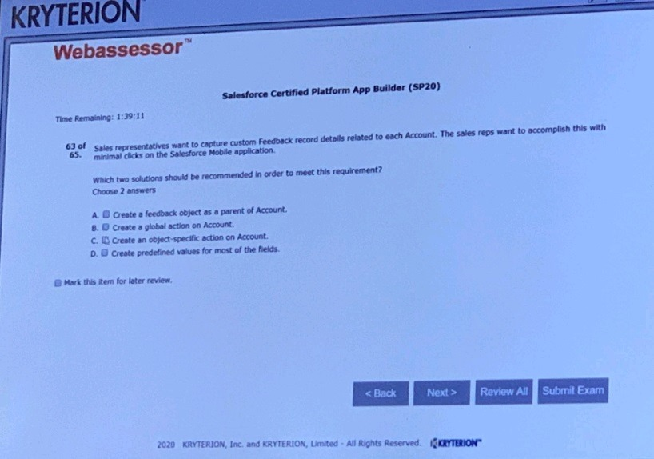

Ans: C,D

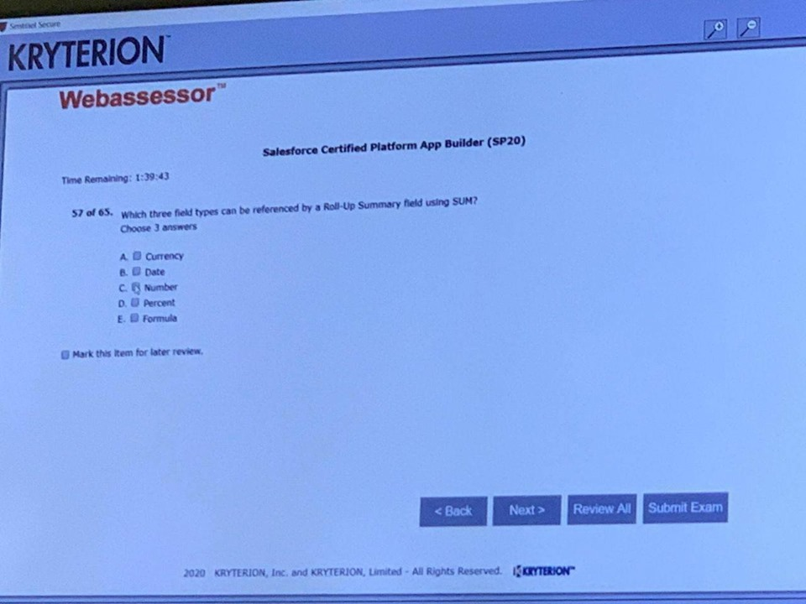

Ans : for sum -Number,Currency,Percent (A,C,D)

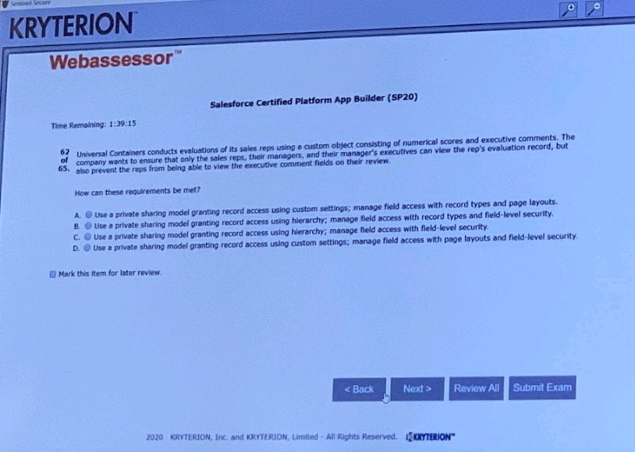

C

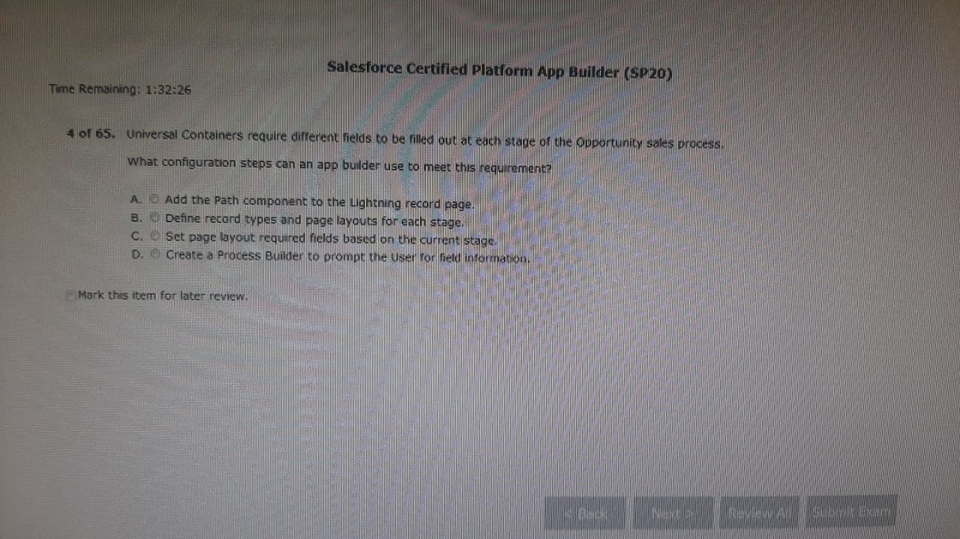

Ans: C- doubt Urvashi

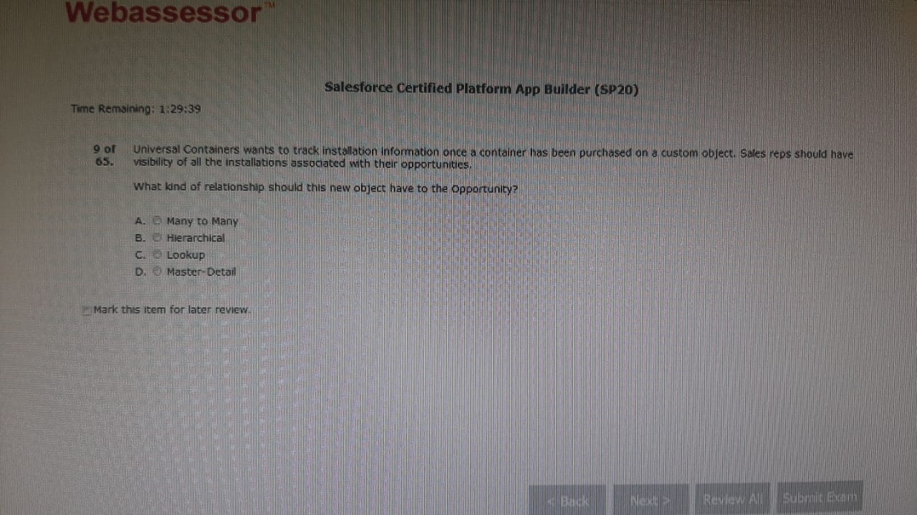

And : D

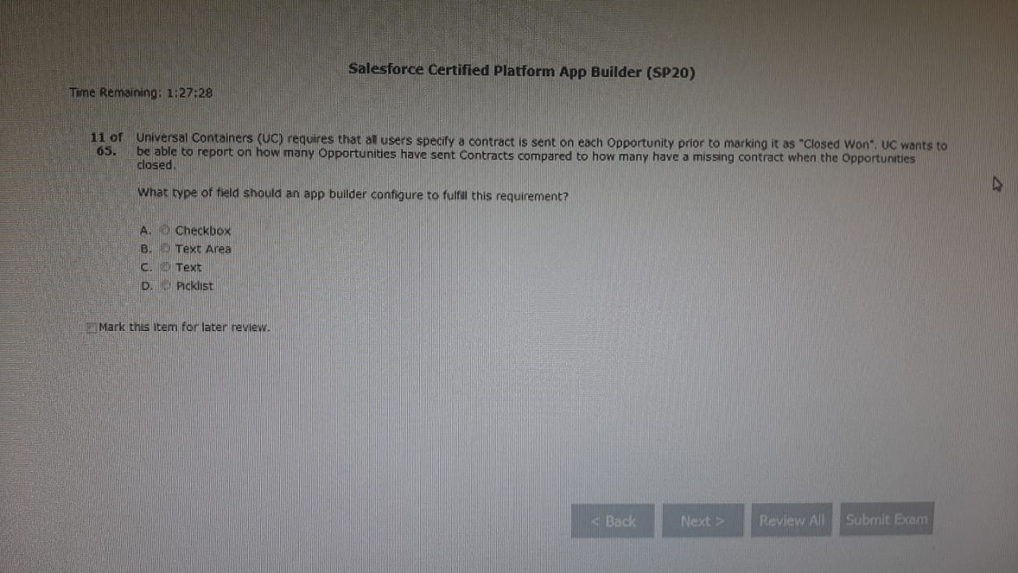

And: A

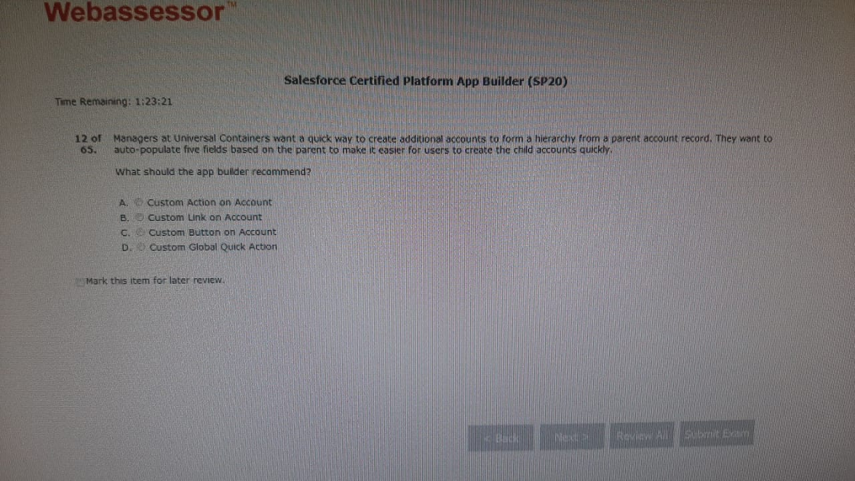

Ans: A Urvashi

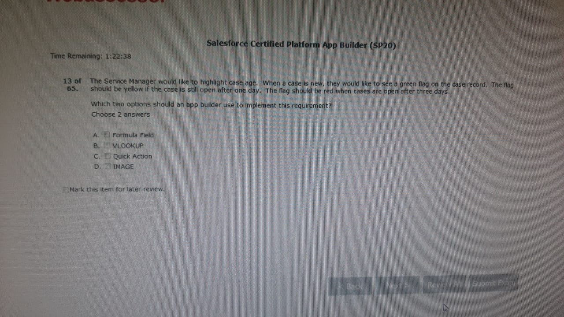

And A,D

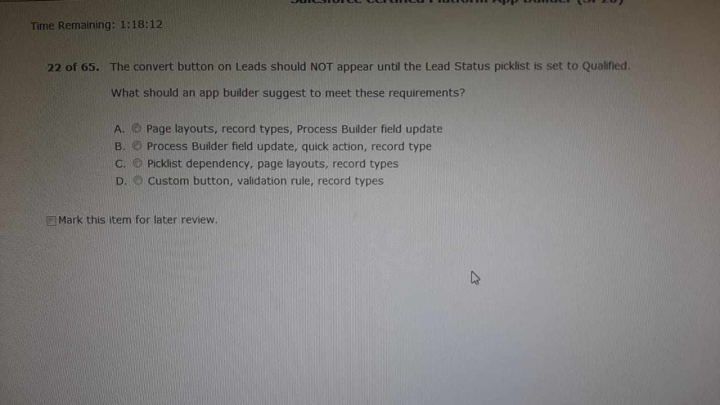

Ans: A

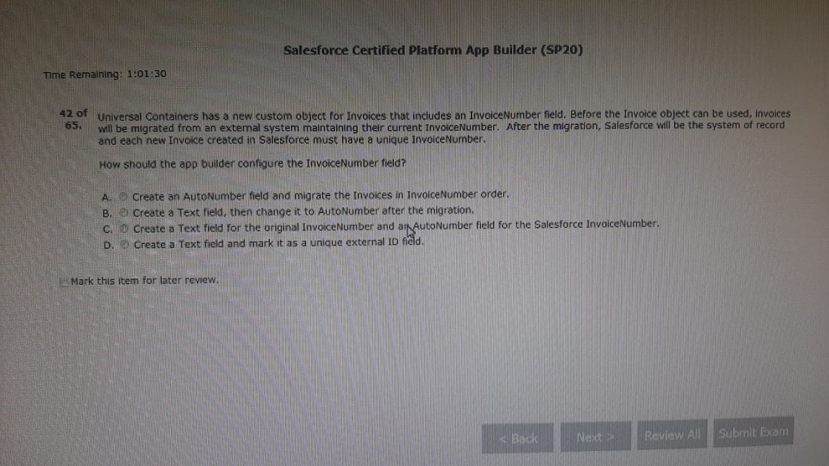Ans: D

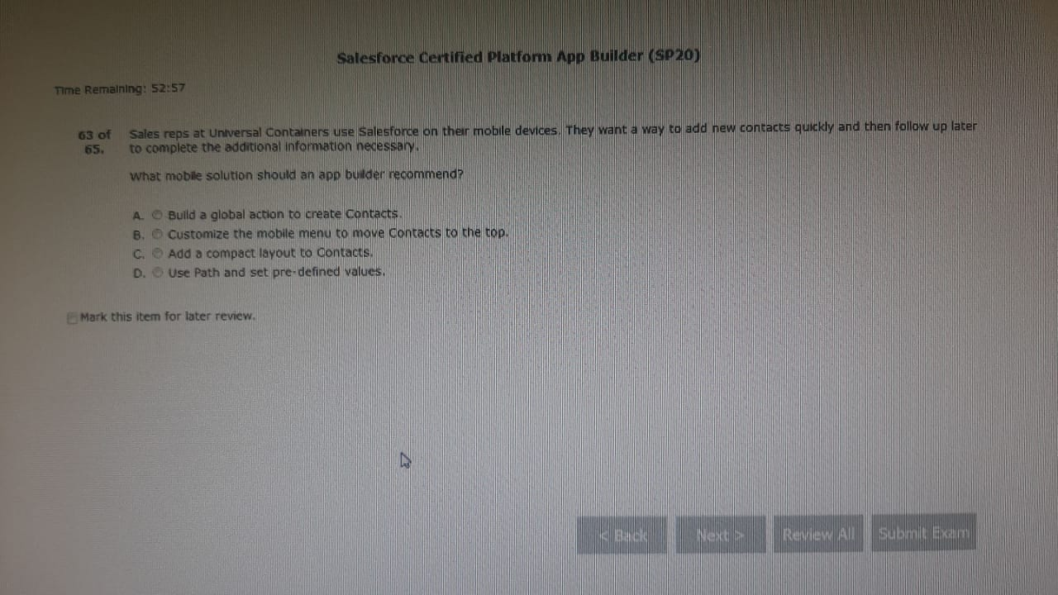

Ans: A

https://trailhead.salesforce.com/en/content/learn/modules/salesforce1_mobile_app/salesforce1_mobile_app_actions_global

[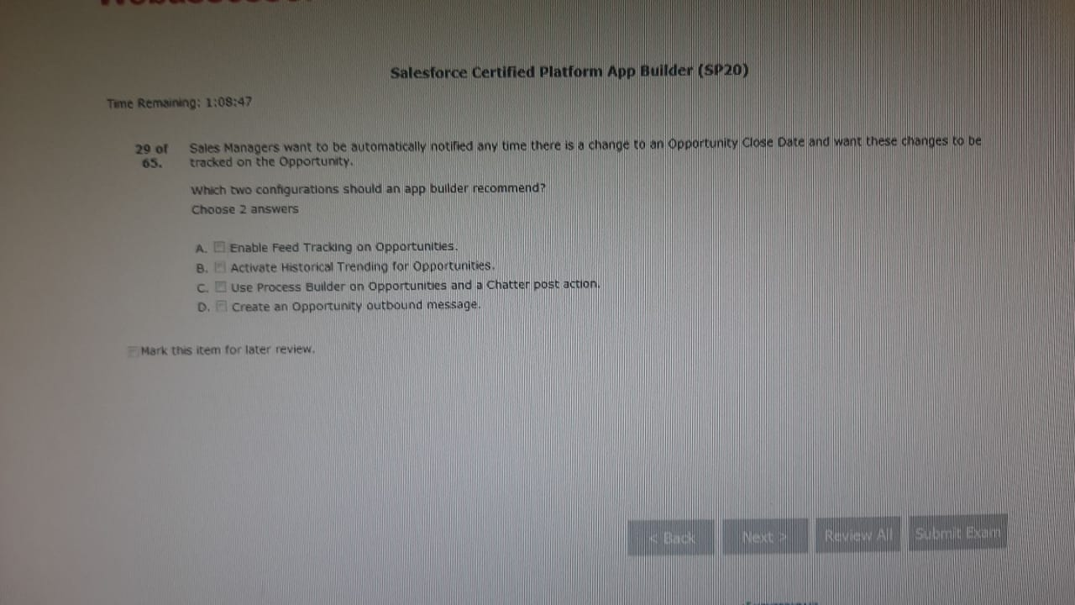Ans](https://trailhead.salesforce.com/en/content/learn/modules/salesforce1_mobile_app/salesforce1_mobile_app_actions_global#Ans) A,B Urvashi

//doubt

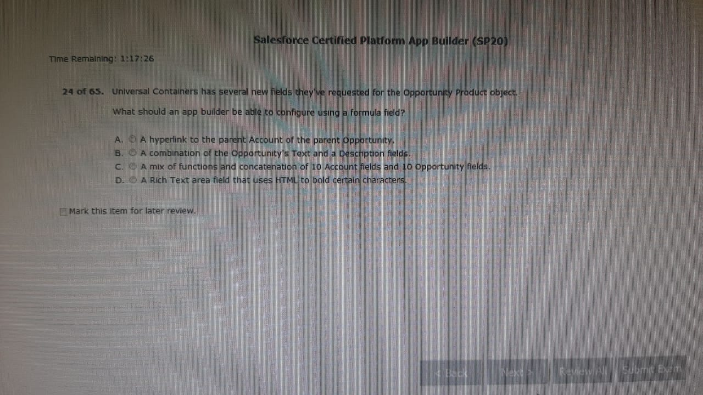

Ans: C

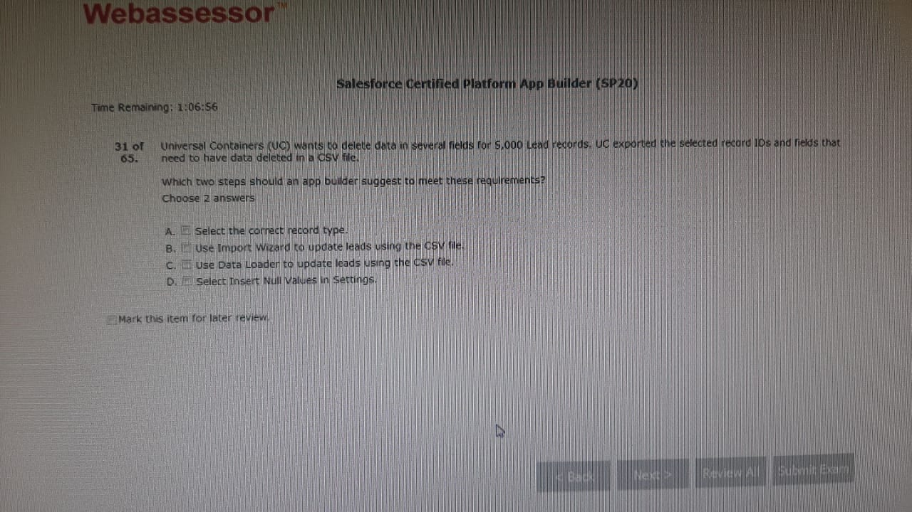

Ans C,D

//doubt

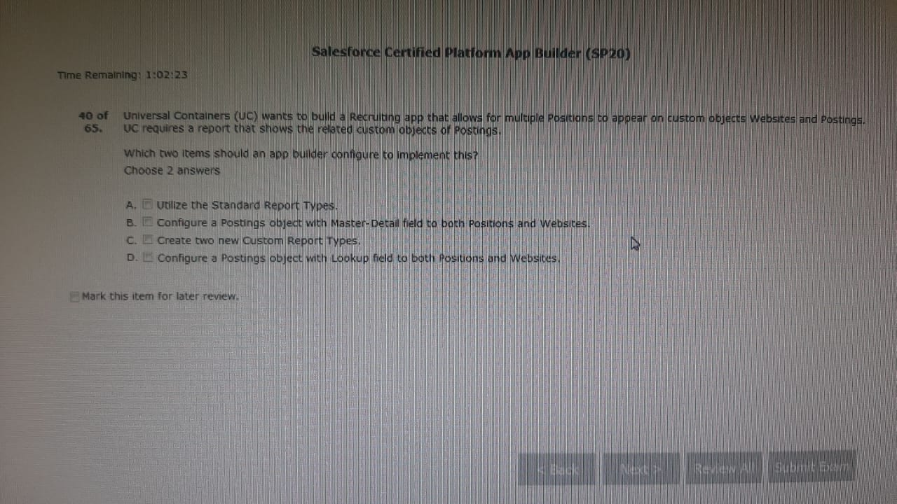Ans: D,A Urvashi

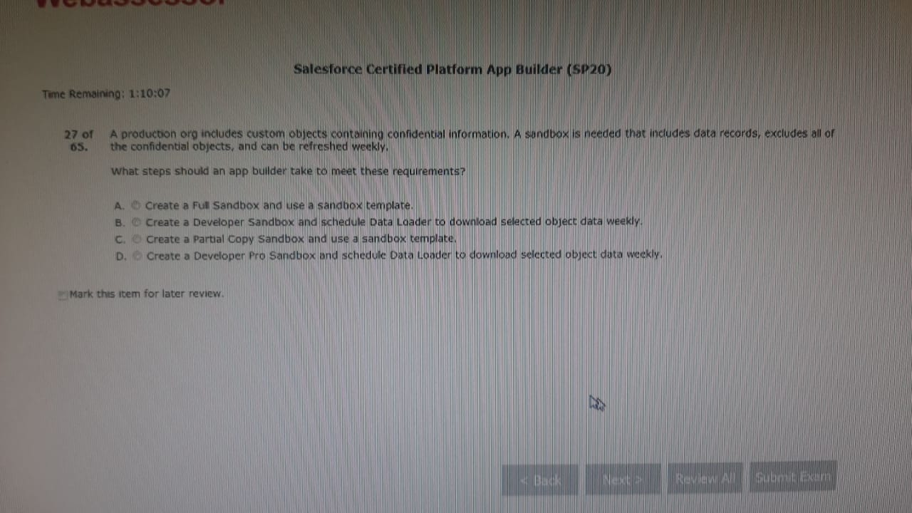

Ans: C (see below details for all sandbox types)

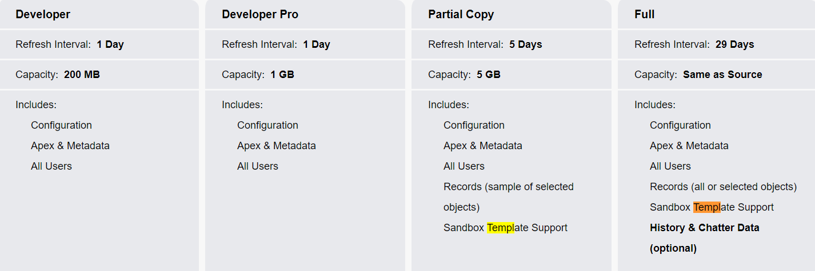

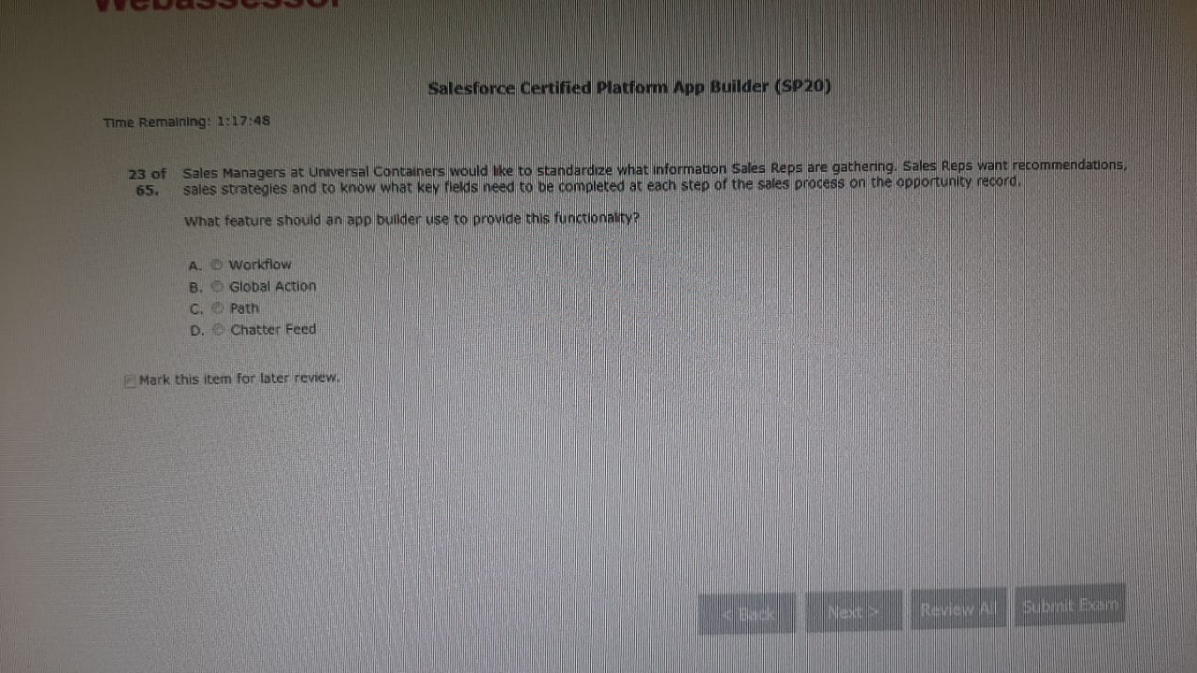Ans: C Urvashi

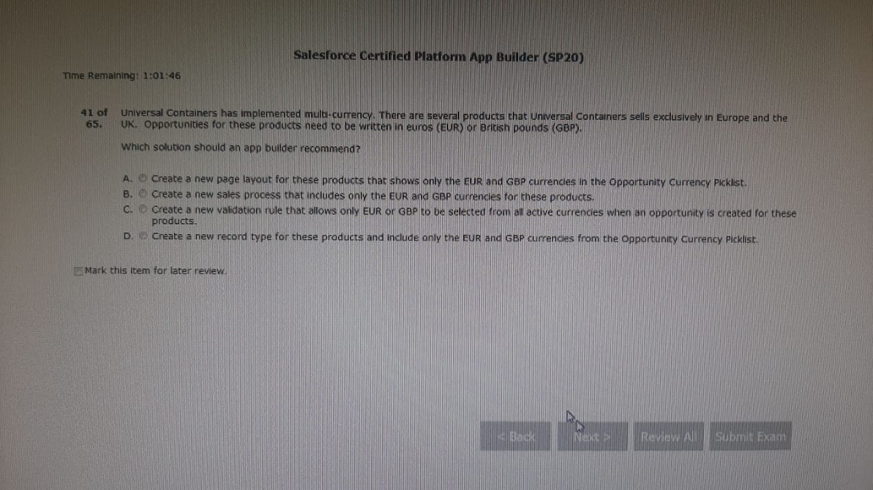

Ans: C

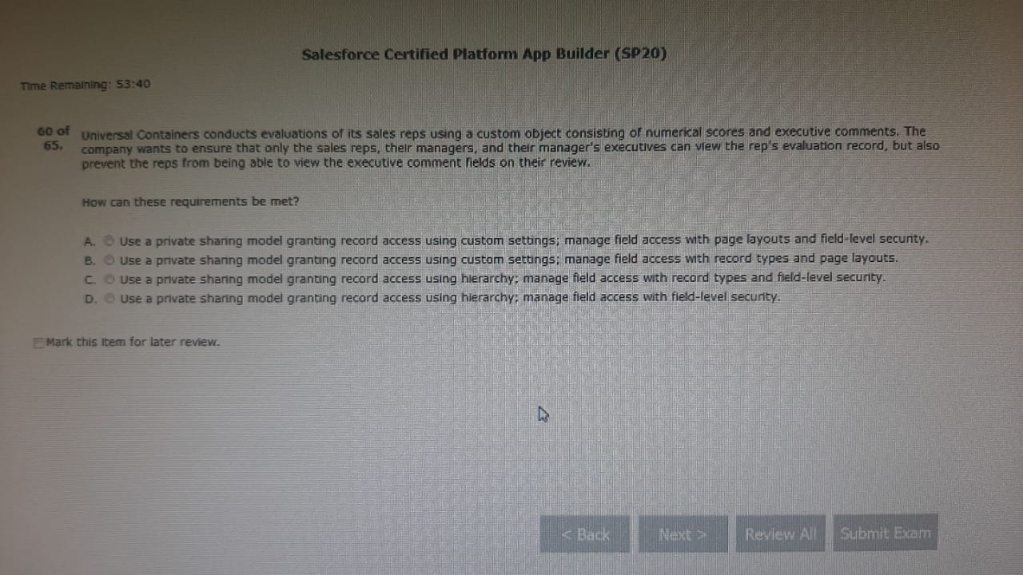

Ans: D

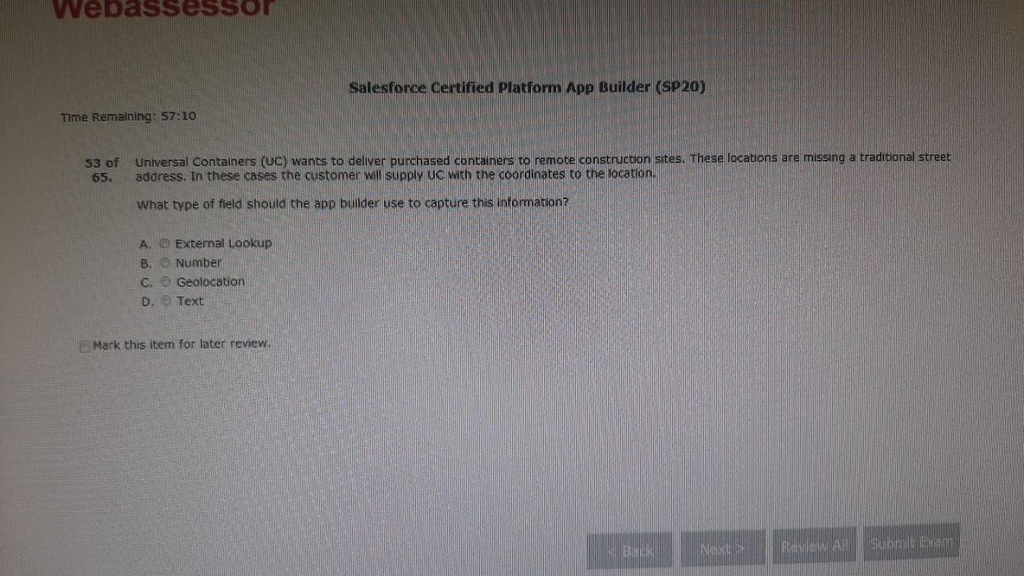

Ans: C Urvashi

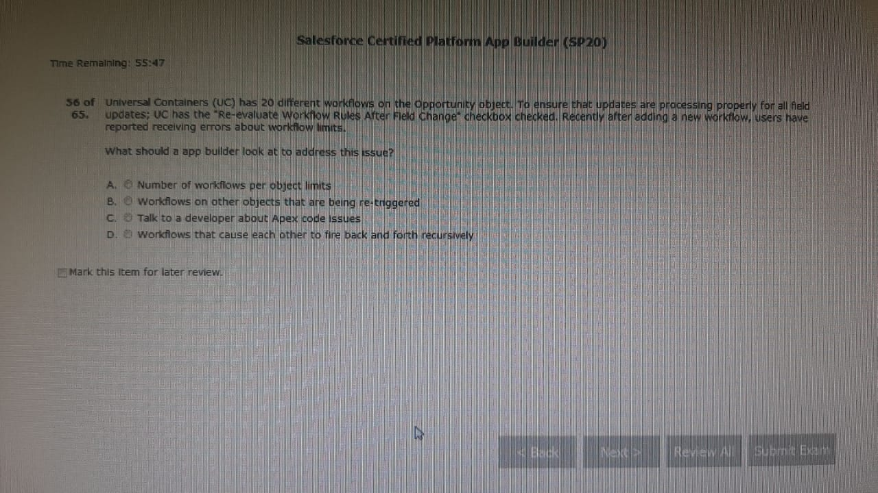

Ans: D

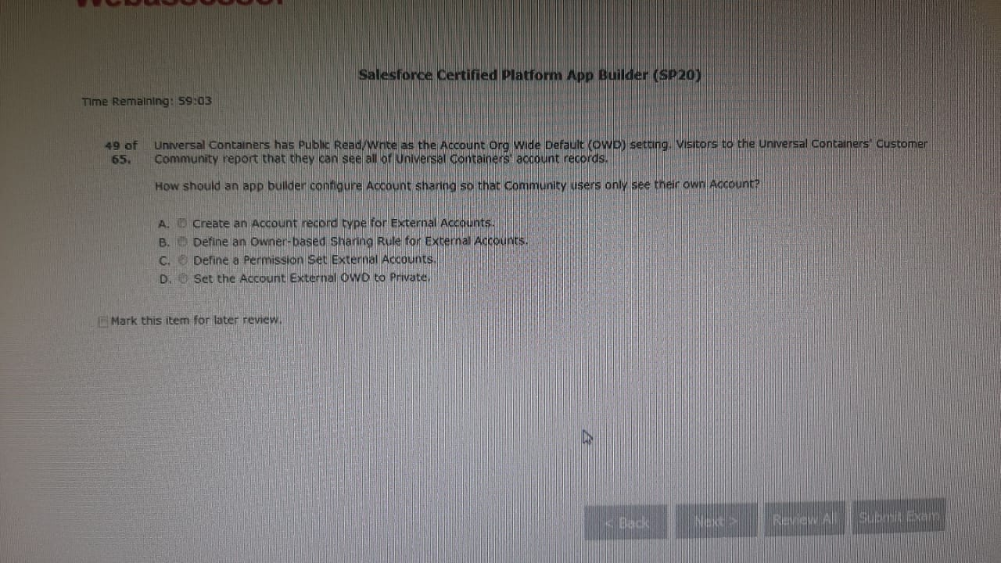

Ans D

//doubt

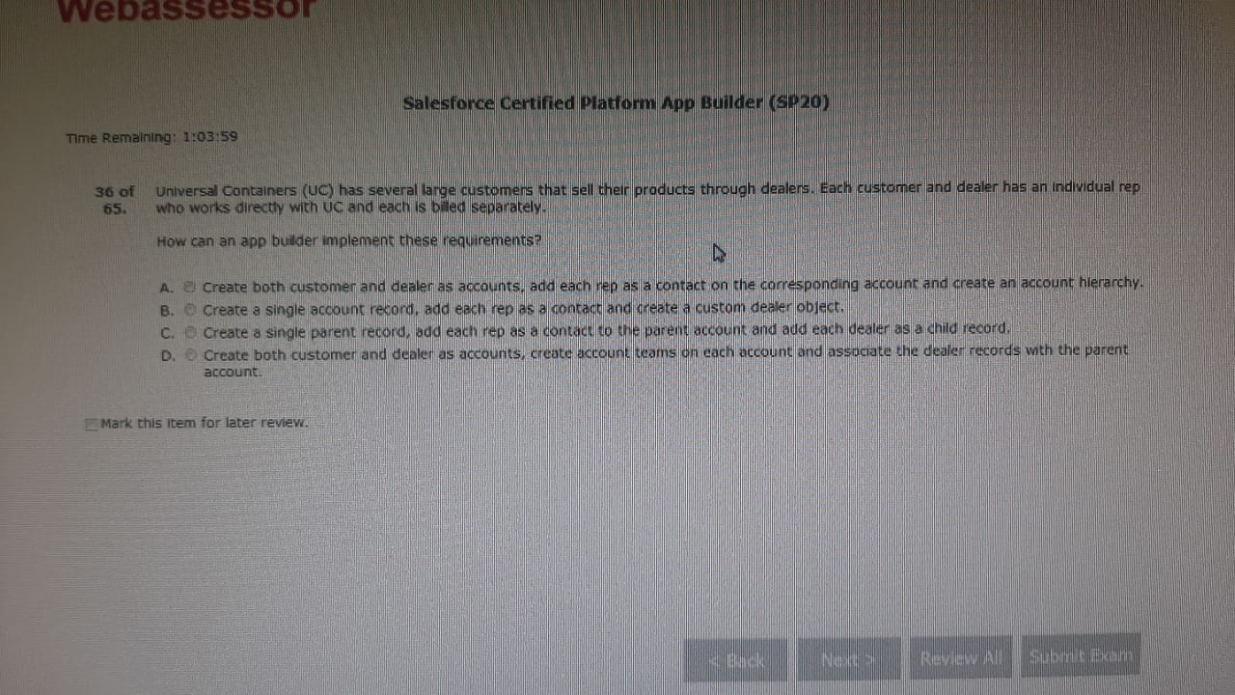

Ans C

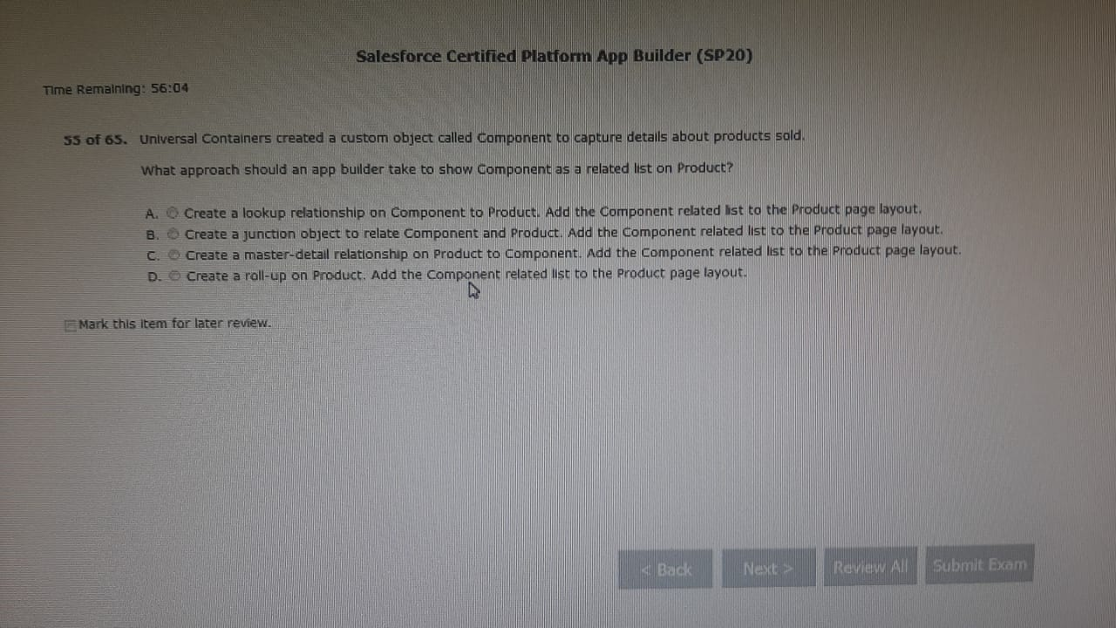

Ans: A Urvashi

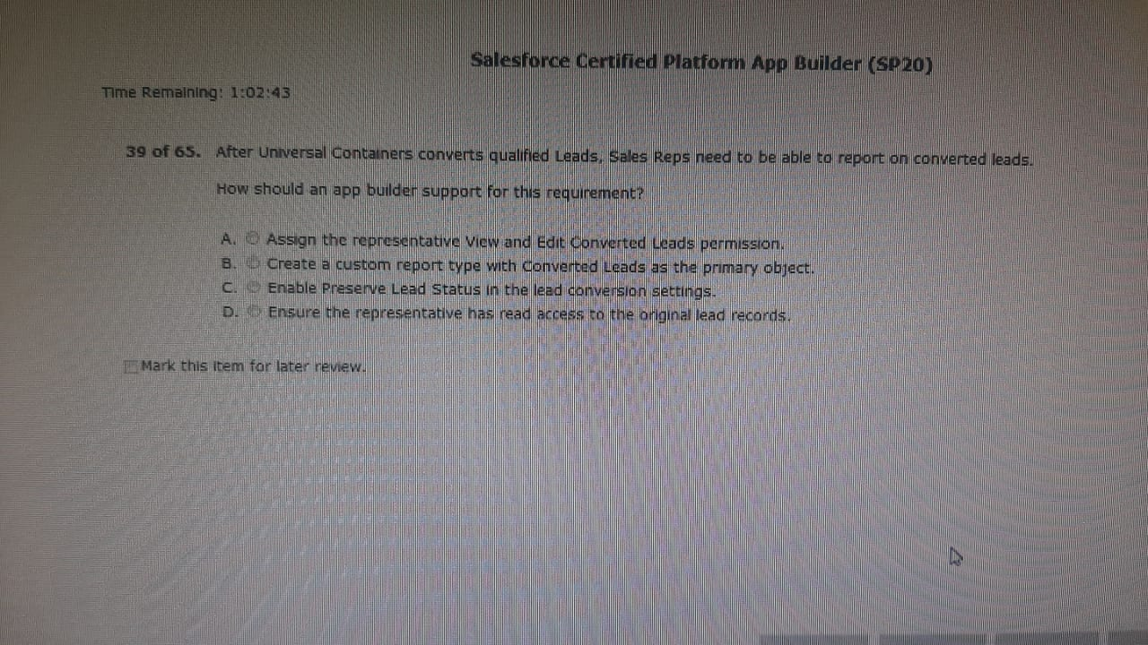

Ans: D

//doubt

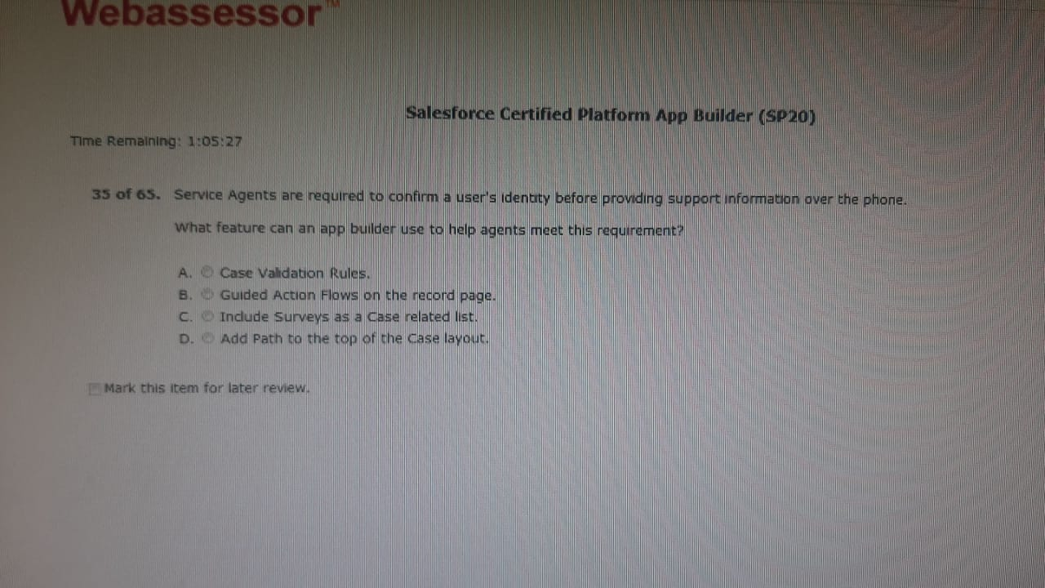

Ans: A

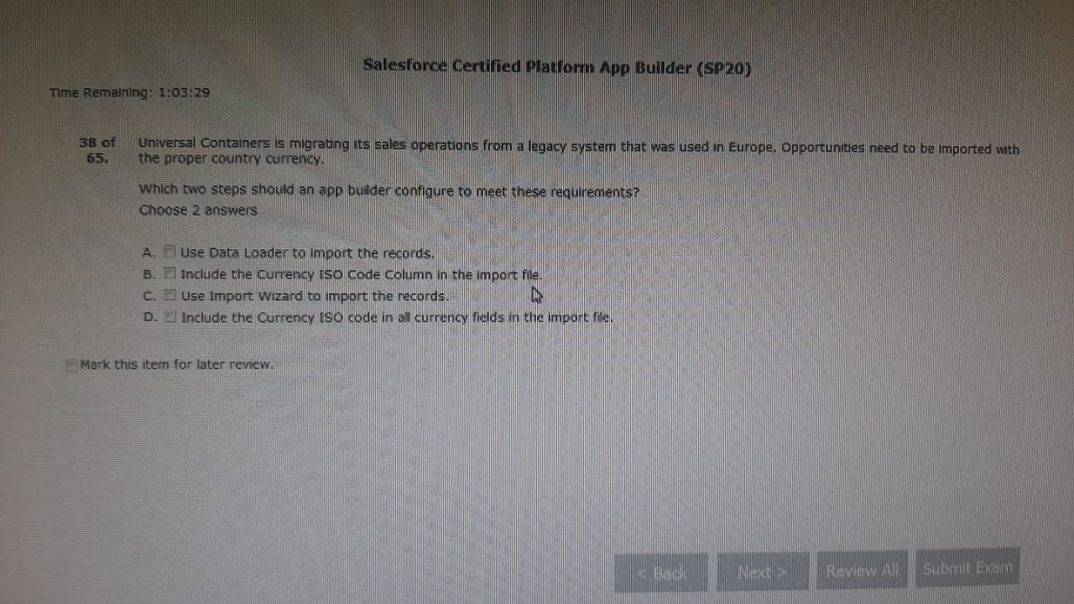

Ans: B,A (Assets, cases, campaigns, contracts, documents, opportunities, and products can’t be imported via import wizards.)

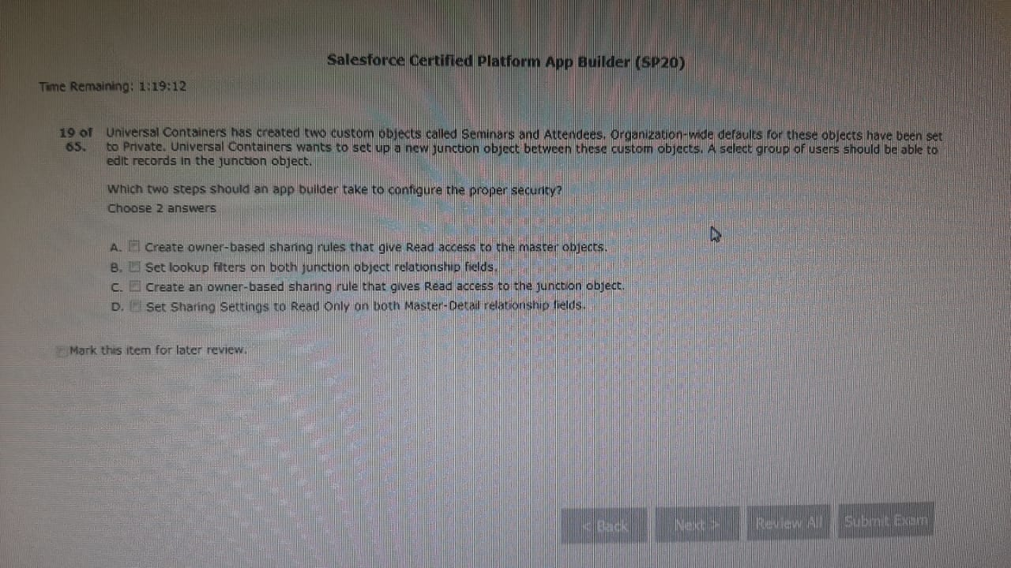

Ans: D, A

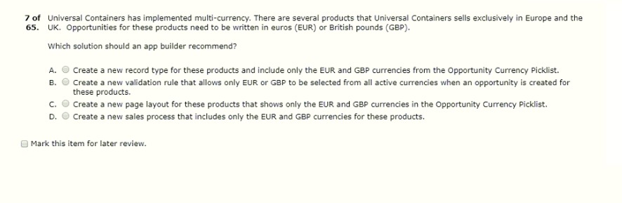

Repeat: Ans B

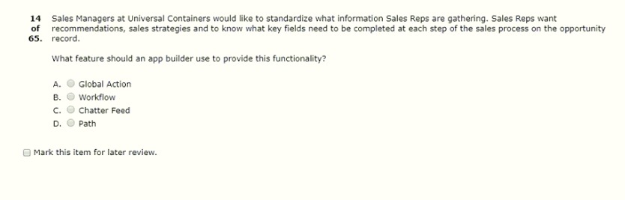Repeat: Ans D

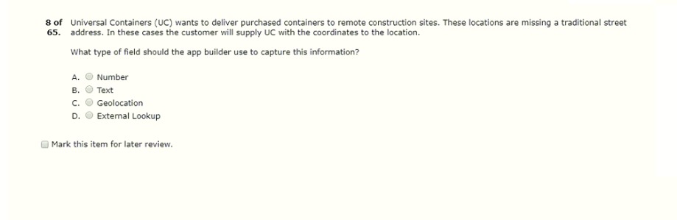

Repeated Ans: C

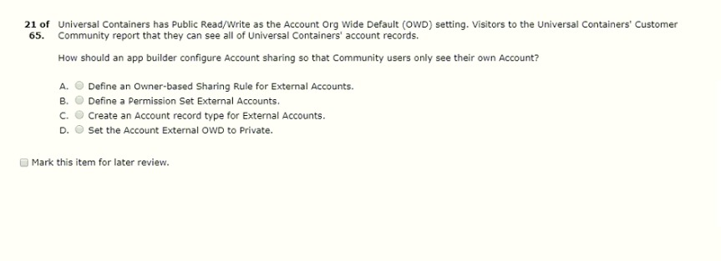

Repeat Ans: D

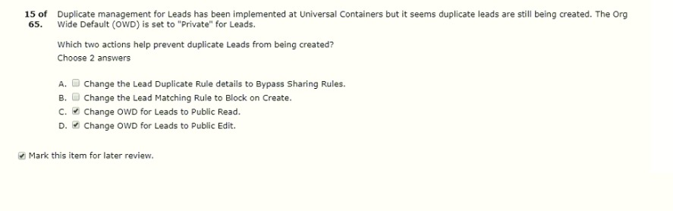

Ans : A,B

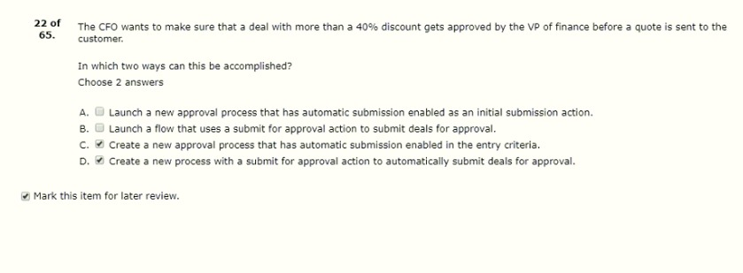

Ans B,D

//doubt

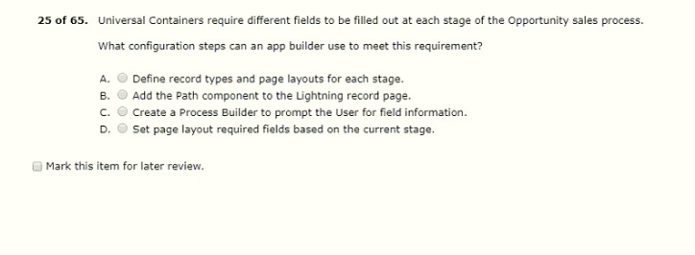

Repeat Ans D

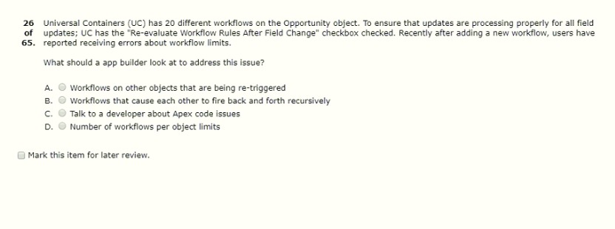

Repeat Ans: B

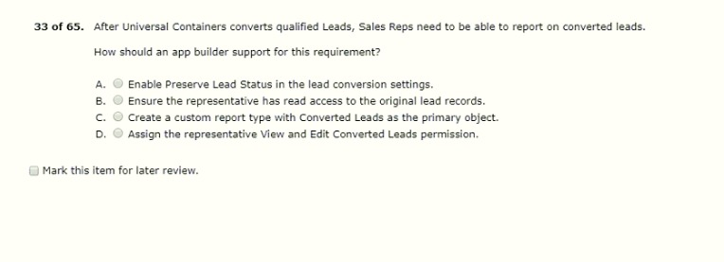

Repeat Ans:D

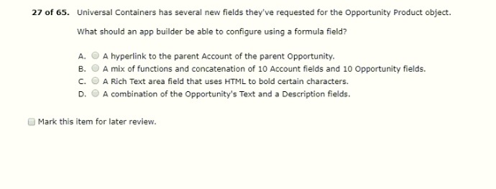

Repeat Ans: B

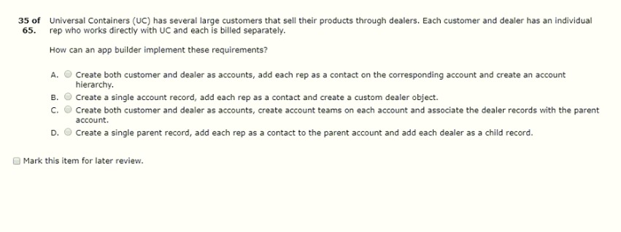

Repeat Ans:A

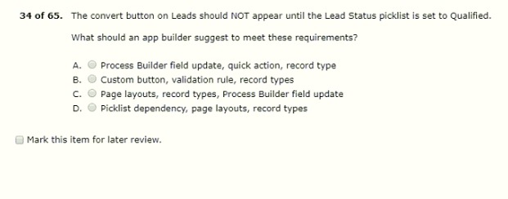

Ans: C

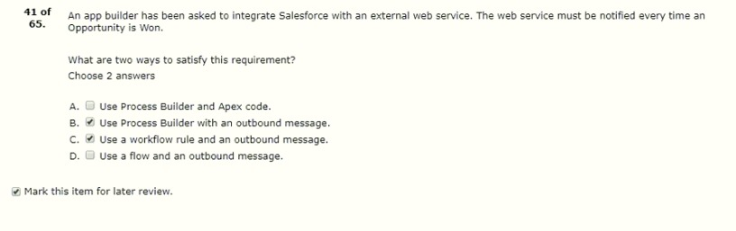

Ans : C,A

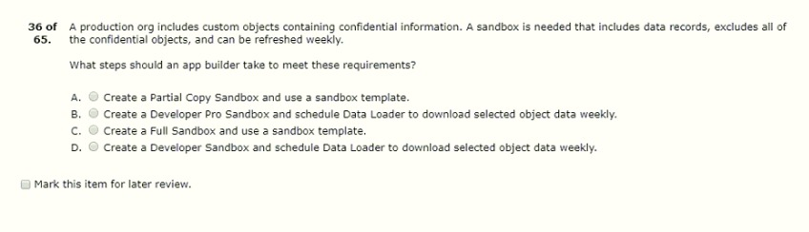

Repeat: Ans A

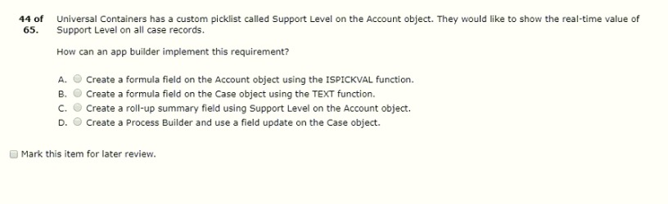

Ans: B

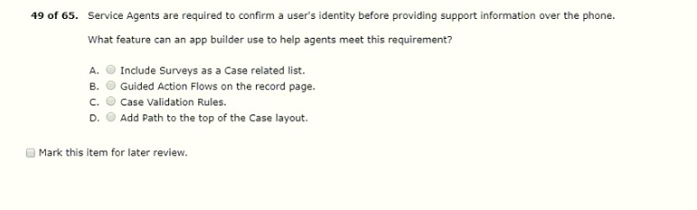

Repeated Ans: C

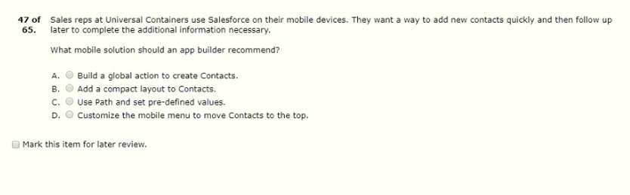

Repeat Ans: A

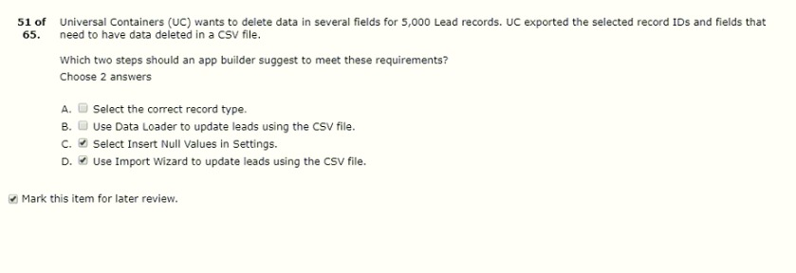

Repeat: Ans: B,C

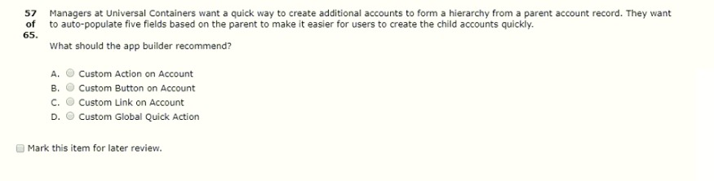

Ans A

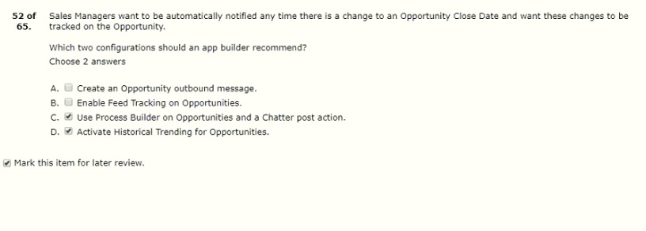

Repeat Ans: B,D

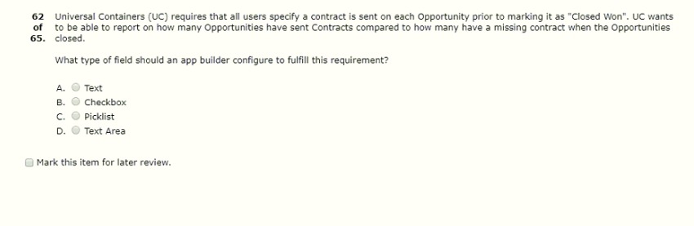

Repeat Ans B

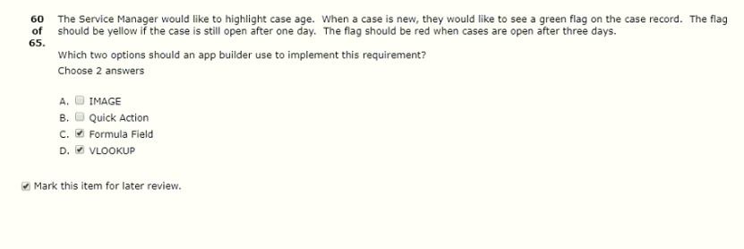

Repeat Ans: A,C

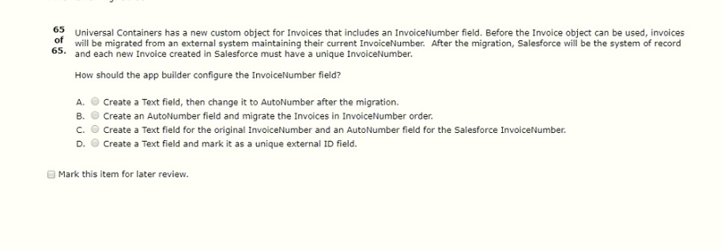

Repeat Ans D

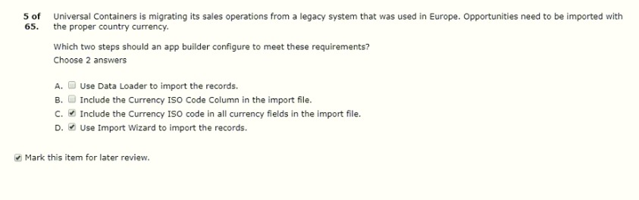

Ans: B,A